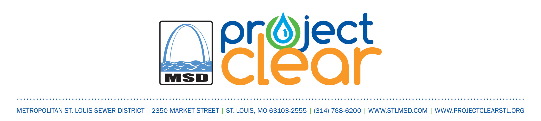

June 1, 2018

Project Number

12092

RE: Bellefontaine #2 Sanitary Relief (Chambers Rd to Coburg Lands Dr) Neighborhood Meeting

Dear Resident:

The Metropolitan St. Louis Sewer District has engaged the services of Wood Environment & Solutions to design improvements for the above referenced project. This project consists of constructing approximately 3,477 lineal feet of 12-inch diameter sanitary sewer. The general area covered by this project is an area north of Chambers Road and east of Ashbrook Drive, in the City of Bellefontaine Neighbors, Missouri. A map has been attached that indicates the limits of this project.

A neighborhood meeting will be held Wednesday, June 20, 2018 at 7:00 pm at City of Bellefontaine Neighbors Recreational Center, located at 9669 Bellefontaine Road, St. Louis, MO 63137. At the meeting, you can review the plans that show the proposed improvements. Representatives from the Metropolitan St. Louis Sewer District and our consultant will be on hand to take your comments and answer questions that you may have regarding the proposed improvements.

If there are any questions about this meeting, please feel free to contact Jennifer Schneider at (636) 200-5151.

Sincerely,

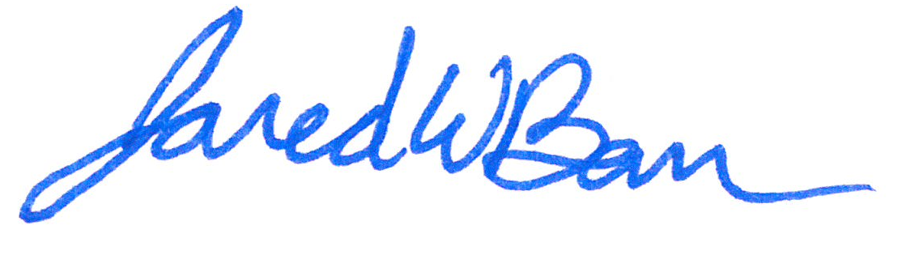

Jared Barr, P.E.

MSD Project Manager

Engineering Department/Program Management Division

Attachment: Neighborhood Meeting Brochure