**Commercial Parking Lots Winter Maintenance**

[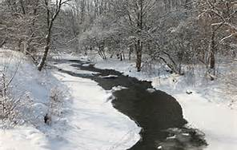](http://www.bing.com/images/search?q=winter+stream+&qs=n&form=QBIR&pq=winter+stream+&sc=8-13&sp=-1&sk=#view=detail&id=FB066A31BF2D5E84C39F01243CE663C27C3B2509&selectedIndex=13)**IMPACTS OF SALT ON OUR STREAMS**

* Sodium Chloride (salt) is routinely applied to parking lots to reduce build up of ice during winter. When salt comes into contact with rainfall and melting snow, it dissolves and the chloride is carried by stormwater runoff into our streams and rivers
* Chloride is toxic to aquatic life in streams

**BEST MANAGEMENT PRACTICES**

* 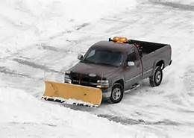Plow, shovel, snow blow, and/or sweep before applying deicing material
* Find out if the entire parking lot needs to be cleaned or just areas with higher traffic
* Effective salt application rates will be different at different pavement temperatures. The table to the right provides application rates based on experienced professionals
* Calibrate spreading equipment following manufacturer’s guidelines
* Pervious asphalt, concrete, and pavers will need little to no deicing
* Sweep after each storm event to prevent slippery situations that are caused by salt accumulation.
* If you have an area that tends to ice up, consider making it a priority to remedy next summer so you won’t need to deice in the future

**SALT STORAGE**

* 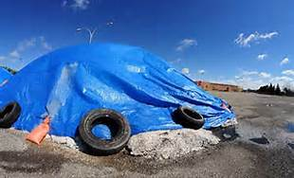Store and cover salt on an impervious surface
* Store salt away from stormwater drains, ditches, ponds, and streams
* Store salt in a location that is not susceptible to rain, snow, or snow melt conditions
* Make sure loading areas are swept back into the pile

**SAVE MONEY**

* Save money by using only the amount of salt that is needed

Additional information: [www.pca.state.mn.us/programs/roadsalt.html](http://www.pca.state.mn.us/programs/roadsalt.html)

****These best management practices are not intended to be policy for winter deicing, but a source of information about deicing best management practices